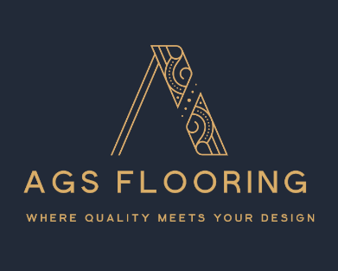

Technical Data Sheet – Jegna Luxury Vinyl Rigid Core Click Herringbone Flooring Rustic Coffee

General Information

Product code | VHB- 8
Brand | Jegna
Installation System | Click
Colour | Rustic Coffee
Width | 126mm
Length | 630mm
Thickness | 6.5mm
Wear Layer | 0.5mm
Weight | 13.5KG Per Pack
Room | Basements, Bathrooms, Conservatories, Dining Rooms, Kitchens, Lounges, Hallways, and Bedrooms.
Construction | Rigid Core
Built-in underlay | Yes 1mm
Edge Profile | Micro Bevelled
Residential Warranty | 25 Years
Water Rating | Waterproof
M2 per a pack | 1.905
Underfloor Heating | Yes- water only
Board Type | SPC Vinyl Flooring Herringbone Wood Effect
Backing | PVC
Surface Finish | Brushed Matt

 | Technical Information
Water Rating | Waterproof
Environmental Rating | Eco- Friendly (more than 50% recycled material)
Fire Resistance | Bfl-S1(EN13501-1)
Slip Resistance | EN13893
Formaldehyde Emission | E1
Resistance to staining | EN14041
Wear Resistance | EN14041
Sound Absorption | 20db(EN IS0717-2)
Electrical Resistance | <2kv (EN1815)
Bacterial Resistance | Good (EN1 ISO846:1999)
European Classification | 34/42 (Suitable for very heavy commercial and light industrial use)

 | Installation Methods
Click system | YES
Glue Down | NO
Floated Underlay | NO (already has built-in 1.5mm underlay)
Over Underfloor Heating | Yes, Water System Only

Subject to a compatible subfloor and proper installation (see the installation and maintenance guide), it is the responsibility of the installation contractor to ensure that floors are installed correctly and safely, considering the specific site conditions, subfloor, and specified finish. This should be carried out in accordance with the installation guidelines, which are designed to align with the current British Standard BS 8201 and any other relevant manufacturer’s instructions.

